Pipe Cleaner Challenge-February

GATE Group
GATE Group this week involved imagination! We find that being creative is something that we need our students to strive for during their many thinking hours at school. At times we “program” so much of their day that we forget how important it is for students to have time to explore and think “Outside the Box.” Well today, your kids had the opportunity to do just that. The Pipe Cleaner Challenge idea was perfect, and here is how it “rolled”.

- Each team was handed 2 basic items…the same amount of tin foil and pipe cleaners.
- Their only instructions were to come up with something creative, and work together. This challenge involved both creative thinking and collaboration.
- The teams were instructed that their “Projects” needed to be finished in 20 minutes.

Our kids have wonderful imaginations and we need to be fostering their creativity. By limiting what supplies were available and presenting this activity as a challenge, it got kids thinking in a new way.
Here are how the materials looked when they were presented to your kids.
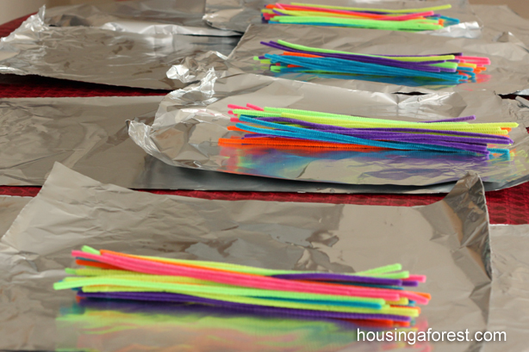

And here are some of the “creations” that our imaginative and creative GATE students completed.
Three Layer Emoji Cake Dagger from Greek Mythology
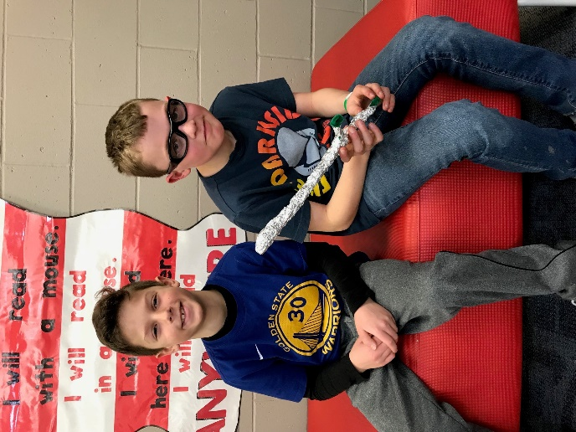
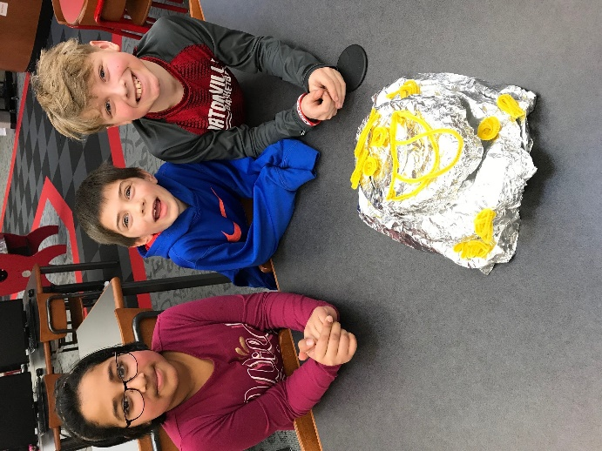

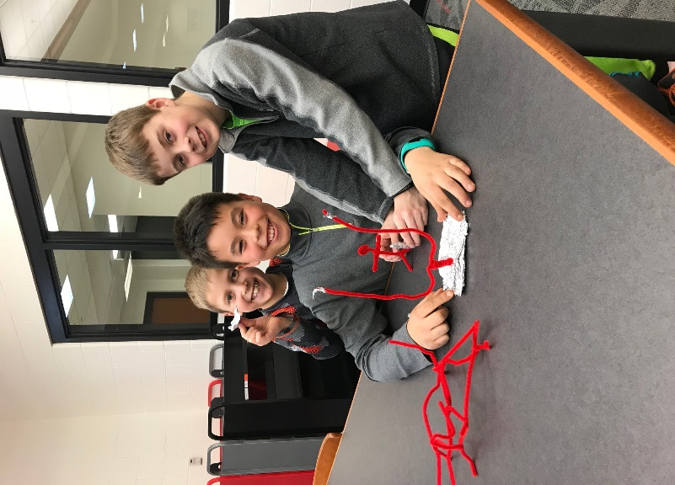
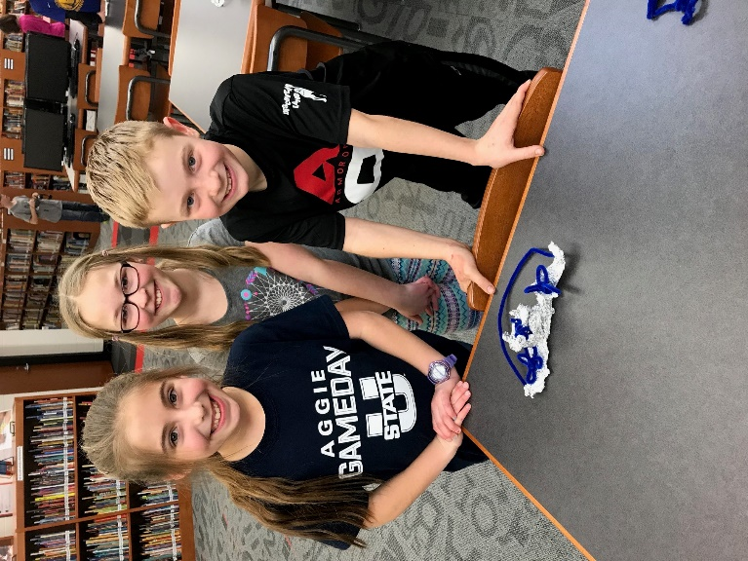
Angel Unicorn in Flowers Football Stadium with Jet

